**8.Raspberry Pi platform -------** **light_follow**

**1)****Preparation**

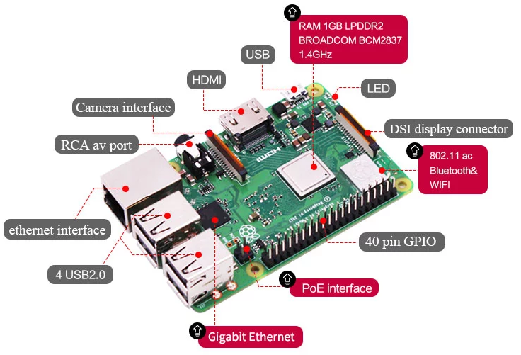

1-1 Raspberry Pi board

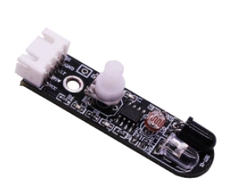

1-2 Infrared obstacle avoidance module

**2)Purpose of Experimental**

After running the light_follow executable in the Raspberry Pi system, you need to press the K2 to start the car, and the light follow function is started. When both light-sensitive resistors detect light, the car advance; when there is light detected on the left side, the car turn left; when light is detected on the right side, the car turn right; when no light is detected on the left and right sides, the car stopped.

**3)Principle of experimental**

The photoresistor is a resistor made by utilizing the photoconductivity of the semiconductor to change the resistance value according to the intensity of the incident light. The incident light intensity, the resistance is reduced, the incident light is weak, and the resistance is increased. If there is light, the level of the pin connected to the photoresistor becomes high level.

**4)Experimental Steps**

4-1 About the schematic

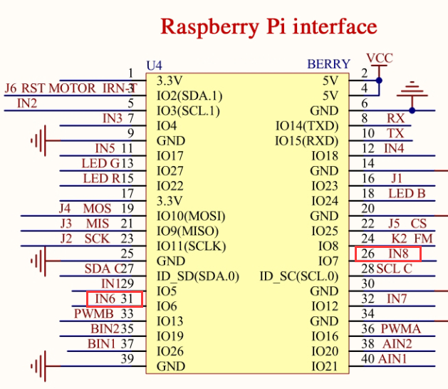

4-1 Raspberry Pi interface circuit diagram

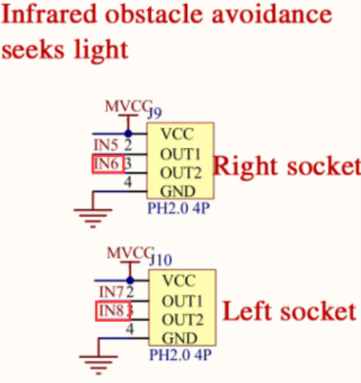

4-2 Left and right infrared sensor interface

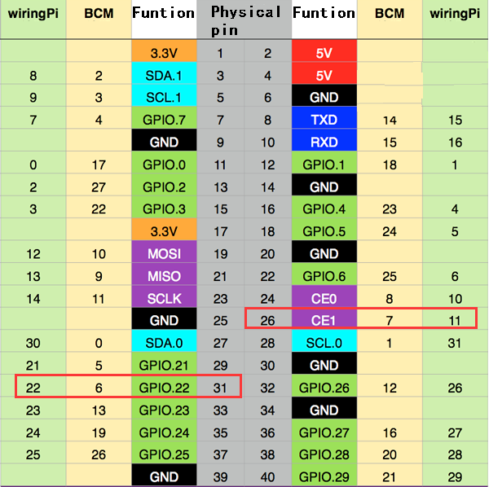

4-3 Raspberry Pi 40 pins comparison table

4-2 According to the circuit schematic:

Left infrared sensor-----26(Physical pin)----- 11(wiringPi)

Right infrared sensor-----31(Physical pin)----- 22(wiringPi)

(Note: We use the wiringPi library to write code.)

（Note: In this experiment, we can adjust the sensitivity of the light follow module by rotating the potentiometer on the infrared module to achieve better experimental results.）

4-3 About the code

1. We need to compile this file in the Raspberry Pi system. (Note: we need to add -lwiringPi to the library file.)

We need to input:gcc light_follow.c -o light_follow -lwiringPi

(2)We need to run the compiled executable file in the Raspberry Pi system.We need to input: ./light_follow

As shown in the figure below.



(3)We can input: ctrl+c to stop this process, which mean is send a signal to the linux kernel to terminate the current process, but the state of the relevant pin is uncertain at this time, we also need to run a script to initialize all pins.

(Note:The initpin.sh script file is included in the SmartCar directory.)

You need to input:  chmod 777 initpin.sh

./initpin.sh

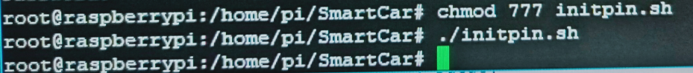

After completing the above steps, the experiment is over.